**ATOC5860 – Application Lab #5**

**Filtering Timeseries**

**Spring 2022**

**Notebook #1 – ATOC5860_applicationlab5**

**ATOC5860_applicationlab5_check_python_convolution.ipynb**

**LEARNING GOAL**

1) Understand what is happening “under the hood” in different python functions that are used to smooth data in the time domain.

Use this notebook to understand the different python functions that can be used to smooth data in the time domain. Compare with a “by hand” convolution function. Look at your data by printing its shape and also values. Understand what the python function is doing, especially how it is treating edge effects.

Convolution results:

Shape of Original Data

(8400,)

Original Data - first three points

[-0.86 -1.03 -1.08]

Convolution by hand - first three points

[-0.29 -0.63 -0.99]

Convolution by hand - last three points

[-1.06 -0.75 -0.37]

The “full” option does the same thing as hand convolution. This is the default.

“Same” returns the same length as the original data. “Valid” is named for the fact that it will only report where signals overlap completely.

**Notebook #2 – Filtering Synthetic Data**

**ATOC5860_applicationlab5_synthetic_data_with_filters.ipynb**

**LEARNING GOALS:**

1) Apply both non-recursive and recursive filters to a synthetic dataset

2) Contrast the influence of applying different non-recursive filters including the 1-2-1 filter, 1-1-1 filter, the 1-1-1-1-1 filter, and the Lanczos filter.

3) Investigate the influence of changing the window and cutoff on Lanczos smoothing.

**DATA and UNDERLYING SCIENCE:**

In this notebook, you analyze a timeseries with known properties. You will apply filters of different types and assess their influence on the resulting filtered dataset.

**Questions to guide your analysis of Notebook #2:**

1. Create a red noise timeseries with oscillations. Plot your synthetic data – Look at your data!! Look at the underlying equation. What type of frequencies might you expect to be able to remove with filtering?

Here are the data:

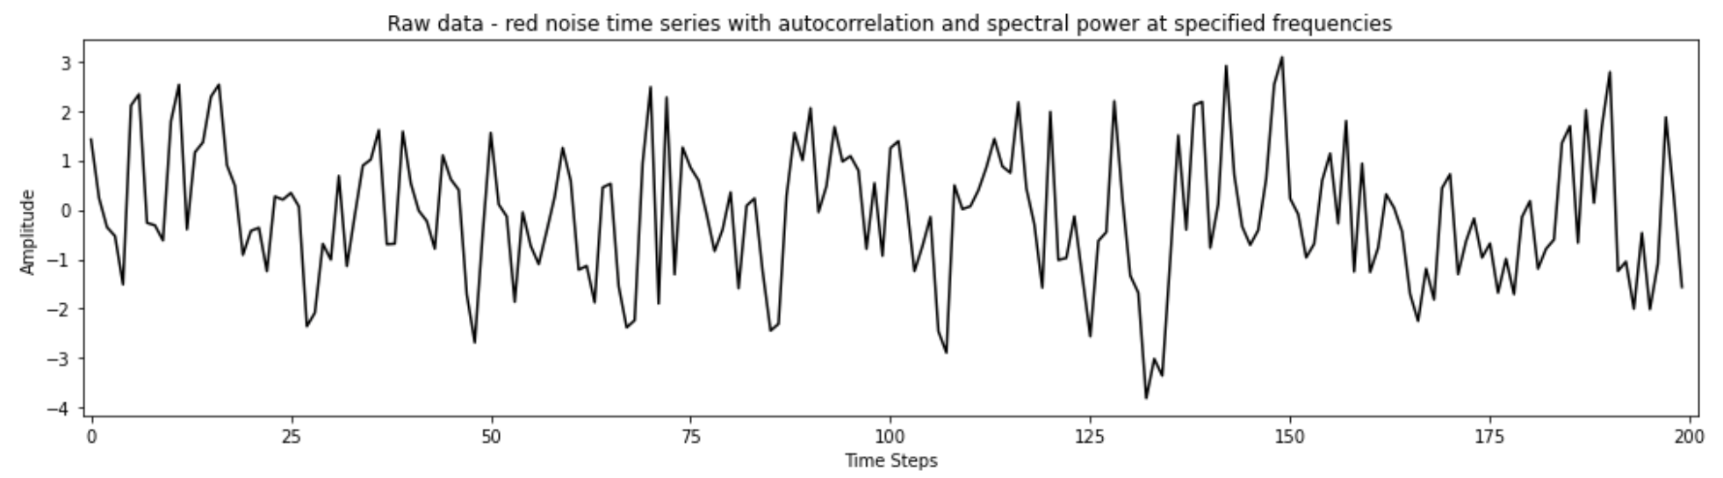

Looks like I could remove some high-frequency noise! The power of low-frequency noise is very low.

1. Apply non-recursive filters in the time domain (i.e., apply a moving average to the original data) to reduce power at high frequencies. Compare the filtered time series with the original data (top plot). Look at the moving window weights (bottom plot). You are using the function “filtfilt” from scipy.signal, which applies both a forward and a backward running average. Try different filter types – What is the influence of the length of the smoothing window or weighted average that is applied (e.g., 1-1-1 filter vs. 1-1-1-1-1 filter)? What is the influence of the amplitude of the smoothing window or the weighted average that is applied (e.g., 1-1-1 filter vs. 1-2-1 filter)? Tinker with different filters and see what the impact is on the filtering that you obtain.

Here's the 1-2-1 filtered data! Also 1-1-1. Looks like they are nearly the same, but 1-2-1 has slightly less smoothing:

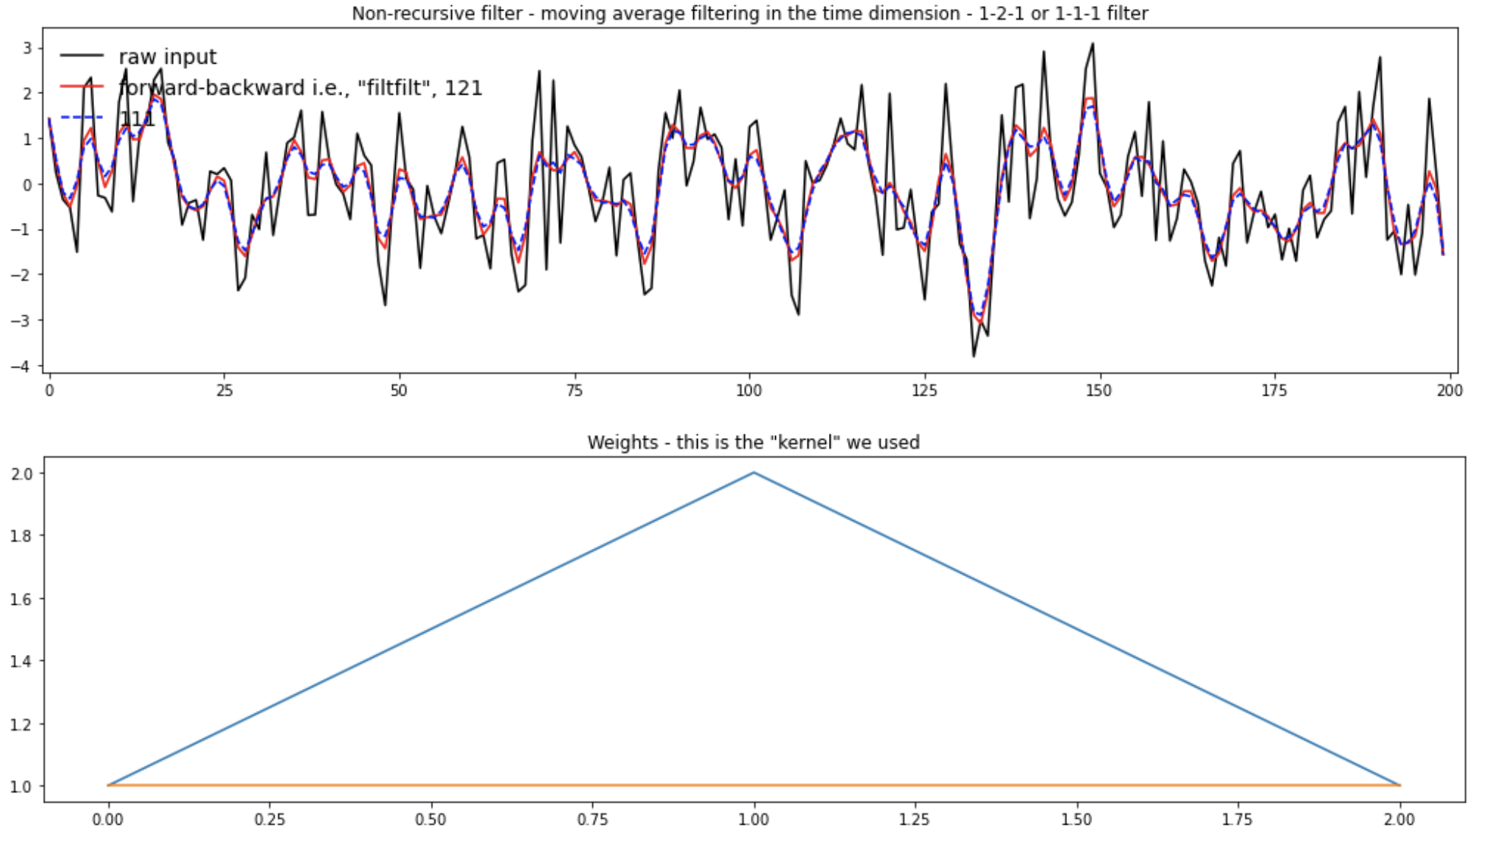

Meanwhile, going to 1-1-1-1-1 provides more smoothing.

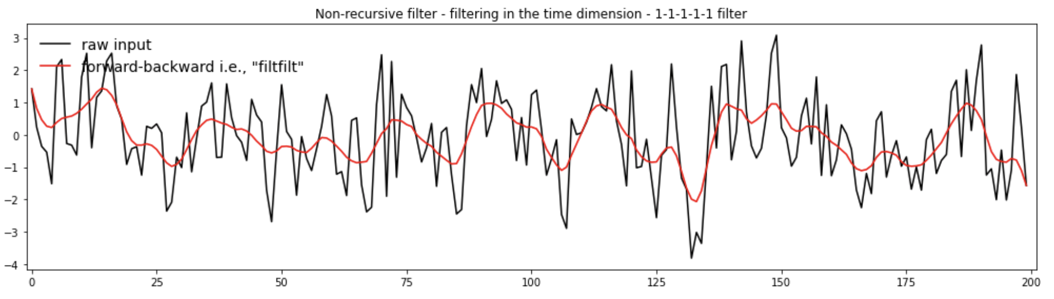

1. Apply a Lanczos filter to remove high frequency noise (i.e., to smooth the data). What is the influence of increasing/decreasing the window length on the smoothing and the response function (Moving Window Weights) in the Lanczos filter? What is the influence of increasing/decreasing the cutoff on the smoothing and the response function?

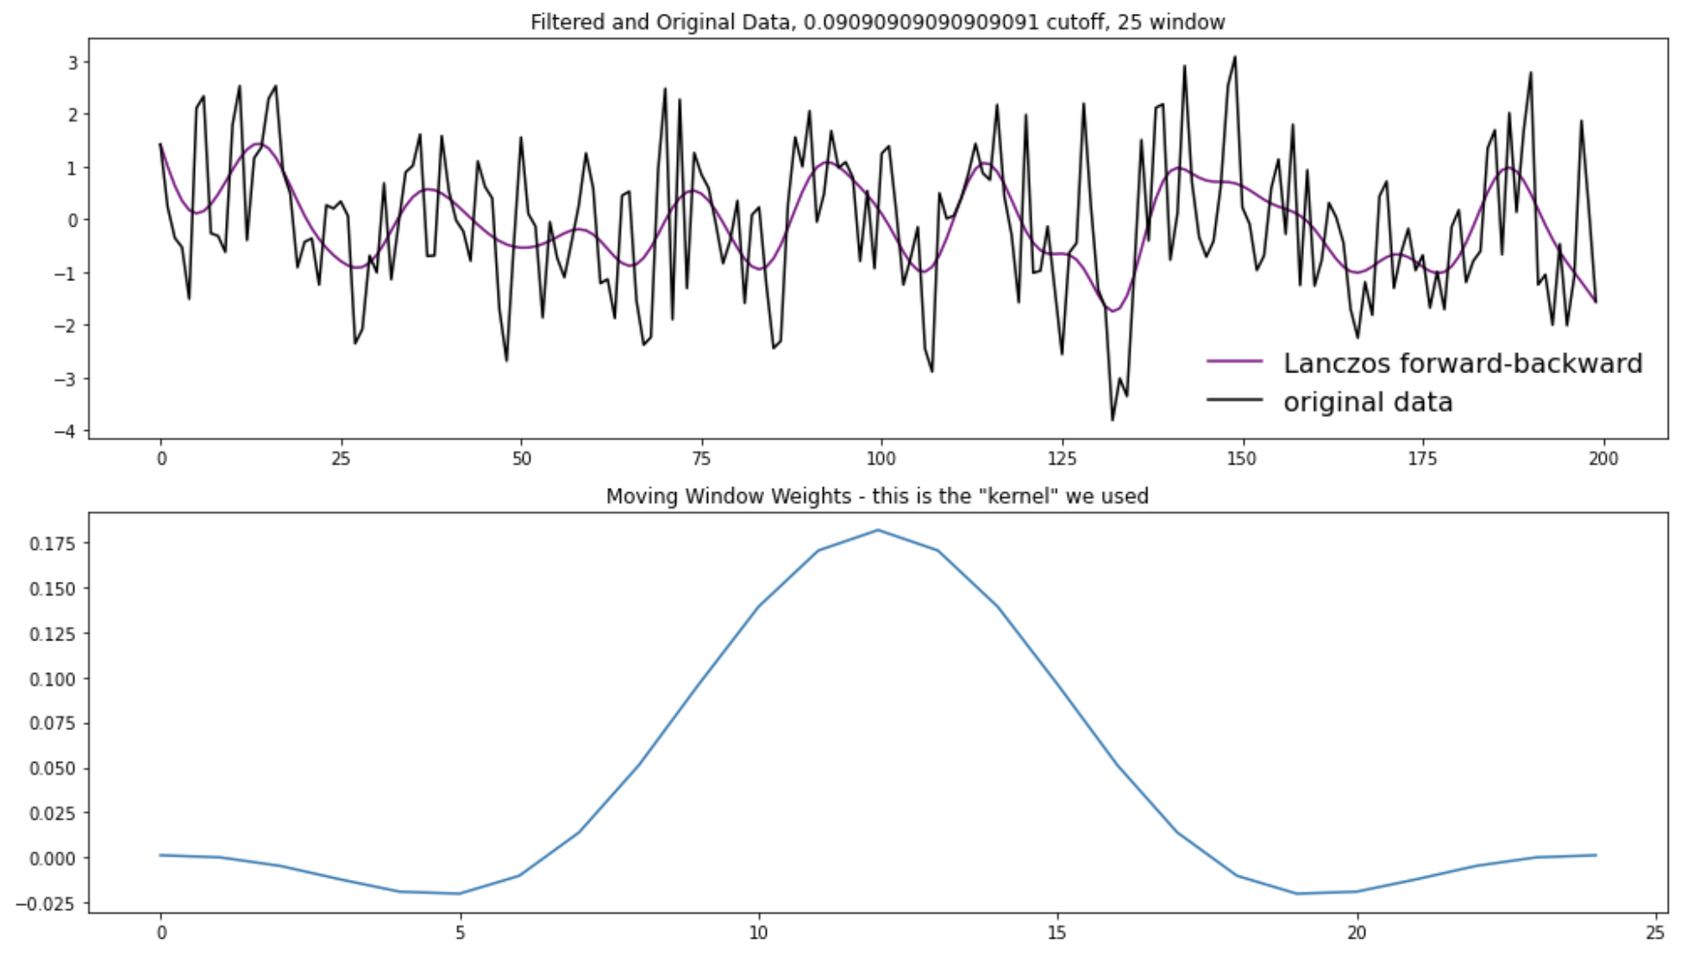

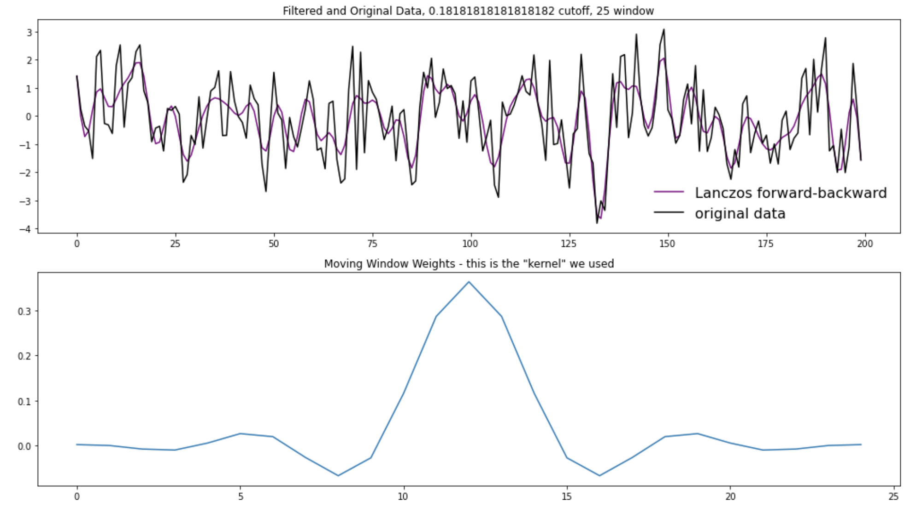

Increasing the cutoff frequency results in less smoothing and a narrower bell with more lobes.

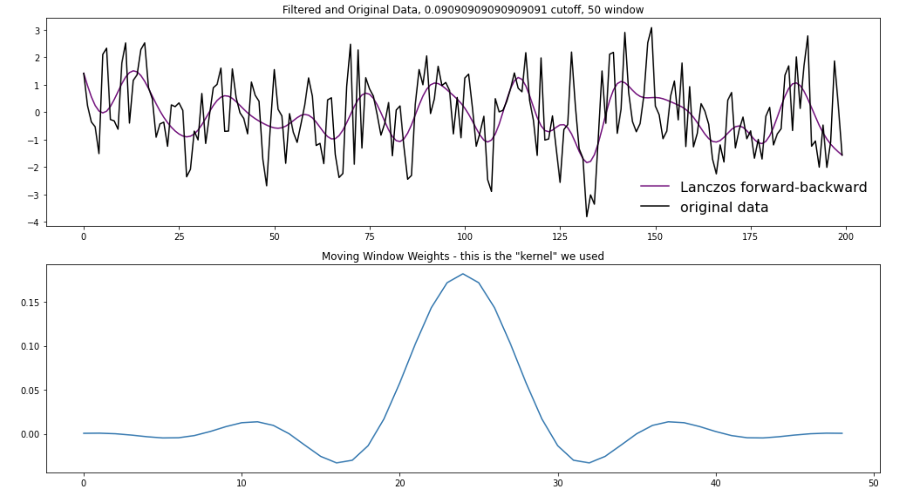

Increasing the length makes the moving window weights curve smoother and gives it more lobes. The amount of smoothing for N = 50 (above) looks comparable to but maybe slightly smoother than N = 25 (first example).

1. Apply a Butterworth filter, a recursive filter. Compare the response function (Moving Window Weights) with the non-recursive filters analyzed above.

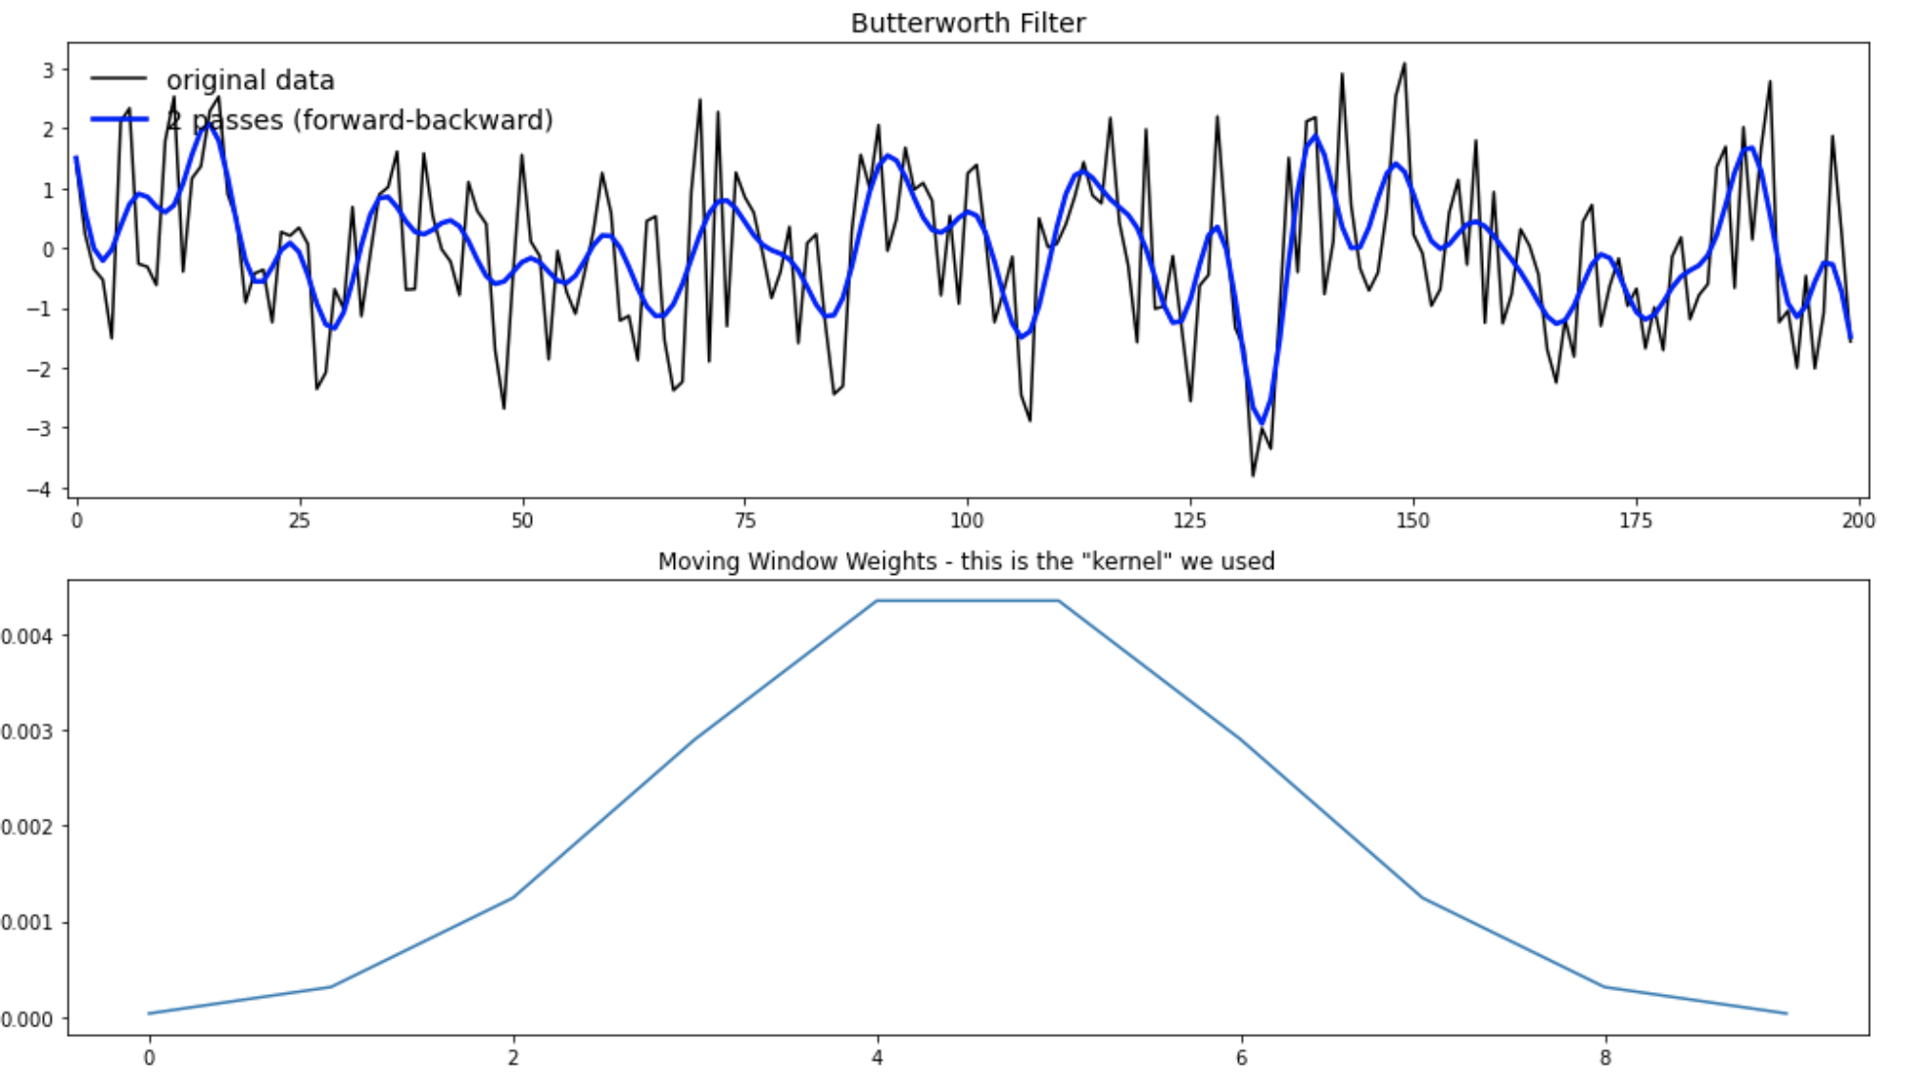

It looks like a Butterworth filter achieves a comparable amount of smoothing as a longer Lanczos filter. I think this is why recursive filters are considered more efficient.

**Notebook #3 – Filtering ENSO data**

**ATOC5860_applicationlab5_mrbutterworth_example.ipynb**

**LEARNING GOALS:**

1) Assess the influence of filtering on data in both the time domain (i.e., in time series plots) and the spectral domain (i.e., in plots of the power spectra).

2) Apply a Butterworth filter to remove power of specific frequencies from a time series.

3) Contrast the influence of differing window weights on the filtered dataset both in the time domain and the spectral domain.

4) Calculate the response function using the Convolution Theorem.

5) Assess why the python function filtfilt is filtering twice.

**DATA and UNDERLYING SCIENCE:**

In this notebook, you analyze monthly sea surface temperature anomalies in the Nino3.4 region from the Community Earth System (CESM) Large Ensemble project fully coupled 1850 control run (http://www.cesm.ucar.edu/projects/community-projects/LENS/). A reminder that an pre-industrial control run has perpetual 1850 conditions (i.e., they have constant 1850 climate). The file containing the data is in netcdf4 format: CESM1_LENS_Coupled_Control.cvdp_data.401-2200.nc

*Does this all look and sound really familiar? It should!! This dataset is the same one you analyzed in Homework #4.*

**Questions to guide your analysis of Notebook #3:**

1. Look at your data! Read in your data and Make a plot of your data. Make sure your data are anomalies (i.e., the mean has been removed). Look at your data. Do you see variance at frequencies that you might be able to remove?

Here are the ENSO data:

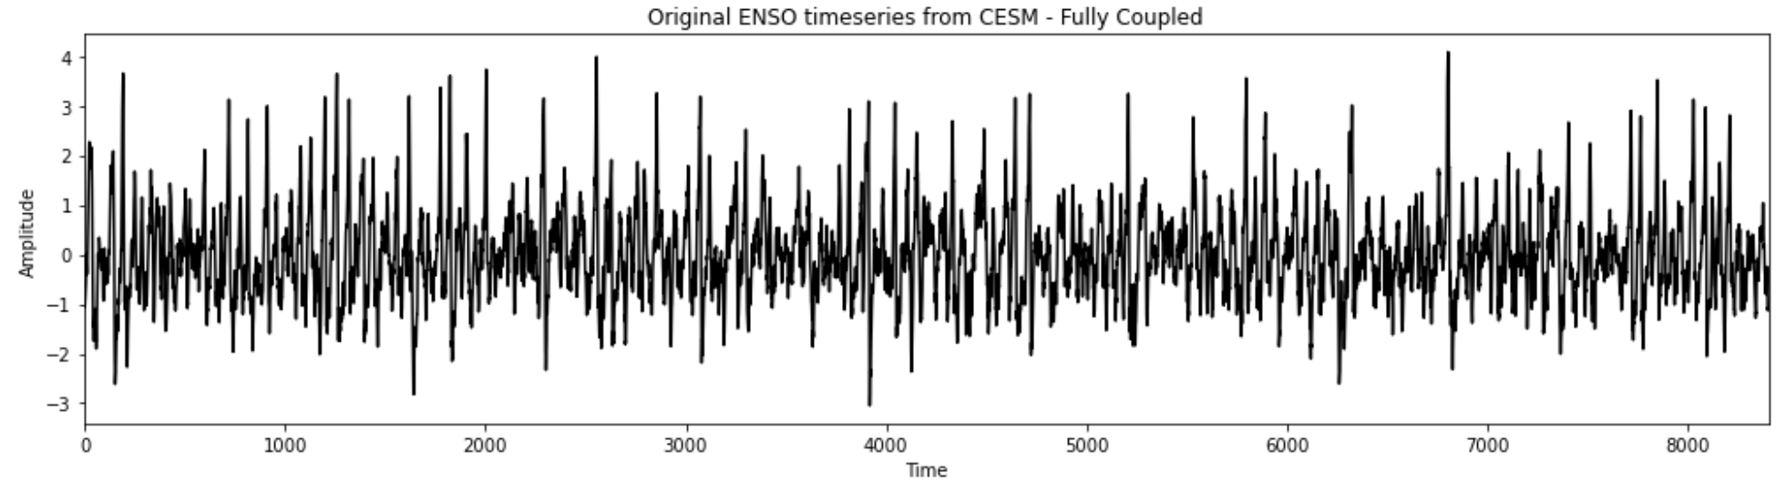

I see a fair amount of power at high frequencies. I’m not sure how important that is. The annual cycle, as Brianna and Megan suggest, may also be removable.

1. Calculate the power spectrum of your original data. Calculate the power spectra of the Nino3.4 SST index (variable called “nino34”) in the fully coupled model 1850 control run. Apply the analysis to the first 700 years of the run. Use Welch’s method (WOSA!) with a Hanning window and a window length of 50 years. Make a plot of normalized spectral power vs. frequency. Where is their power that you might be able to remove with filtering?

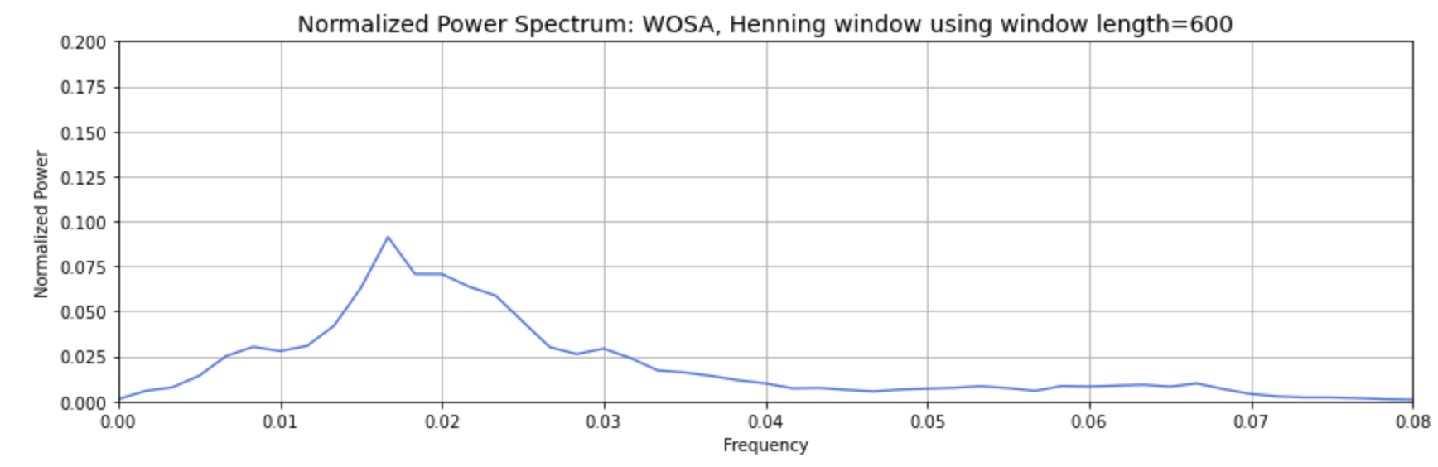

The fact that there’s power at a frequency doesn’t mean it’s not valuable. So I don’t necessarily want to filter it out. That said, spectral power can be removed wherever there are peaks. For example, the peak at 0.017 /month could plausibly be removed with filtering, but that doesn’t mean I want to. I do suspect that frequencies above 0.04/month are noise, but I can’t prove it.

1. Apply a Butterworth Filter. Use a Butterworth filter to remove all spectral power at frequencies greater than 0.04 per month (i.e., less than 2 year). Use an order 1 Butterworth filter (N=1, 1 weight). Replot the original data and the filtered data. Calculate the power spectra of your filtered data. Assess the influence of your filtering in both in time domain (i.e., by comparing the original data time series and filtered time series data) and the frequency domain (i.e., by comparing the power spectrum of the original data and the power spectrum of the filtered data). Look at the response function of the filter in spectral domain using the convolution theorem. Well that was pretty boring… we still have most of the power retained….

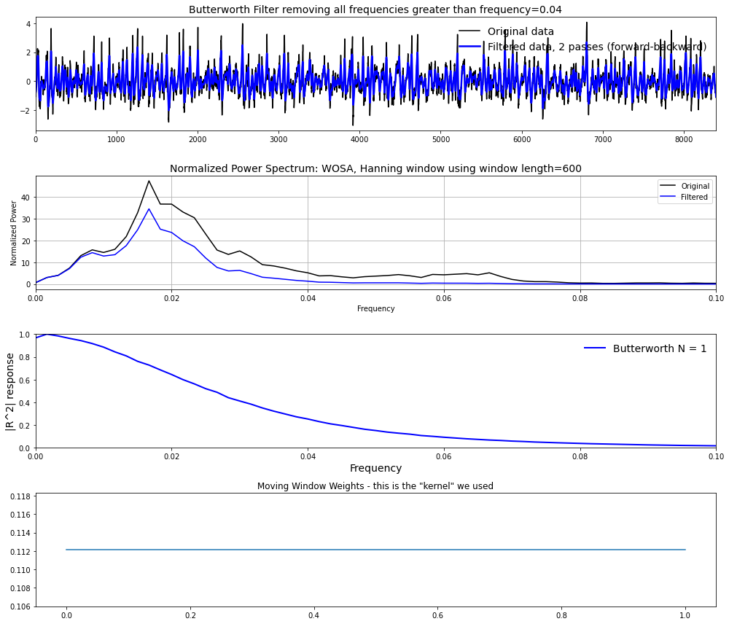

In the timeseries, filtering seems to reduce the height of the “spikes”—the high frequency power. The lower-frequency data aren’t as affected. This is confirmed in the power spectrum: there are only small reductions in the low-frequency power, but power above 0.04 /month is reduced to basically nothing. The response function has a very, very shallow slope. Maybe we can get this to be steeper.

4) Let’s apply another Butterworth Filter and this time really get rid of ENSO power!. Let’s really have some fun with the Butterworth filter and have a big impact on our data... Let’s remove ENSO variability from our original timeseries. Apply the Butterworth filter but this time change the frequency that you are cutting off to 0.01 per month (i.e., remove all power with timescales less than 8 years). Use an order 1 filter (N=1). Replot the original data and the filtered data. Calculate the power spectra of your filtered data. Assess the influence of your filtering in both in time domain (i.e., by comparing the original data time series and filtered time series data) and the frequency domain (i.e., by comparing the power spectrum of the original data and the power spectrum of the filtered data). Look at the response function of the filter in spectral domain using the convolution theorem.

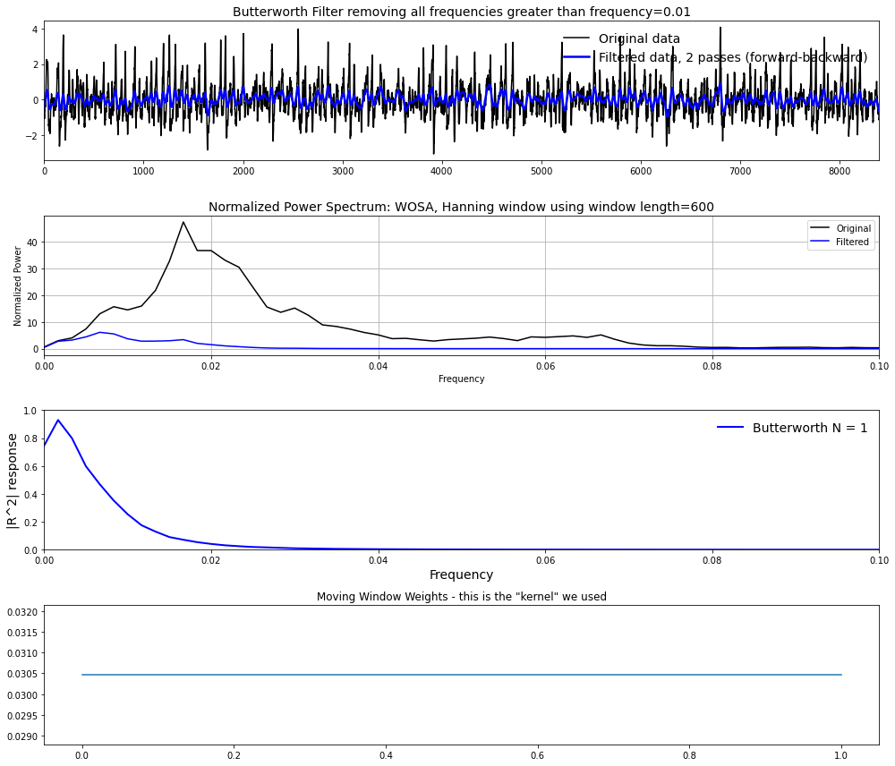

There is absolutely still *some* power at frequencies above 1 per 8 years. But that power is significantly reduced. I’m intrigued that the response function decreases at extremely low frequencies (going to zero, which, to be fair, isn’t really defined). I wonder why this is happening.

1. Let’s apply yet another Butterworth Filter – and this time one with more weights. Repeat step 4) but this time change the order of the filter. In other words, increase the number of weights being used in the filter by increasing the parameter N in the jupyter notebook. What is the impact of increasing N on the filtered dataset, the power spectra, and the moving window weights? You should see that as you increase N – a sharper cutoff in frequency space occurs in the power spectra. Why?

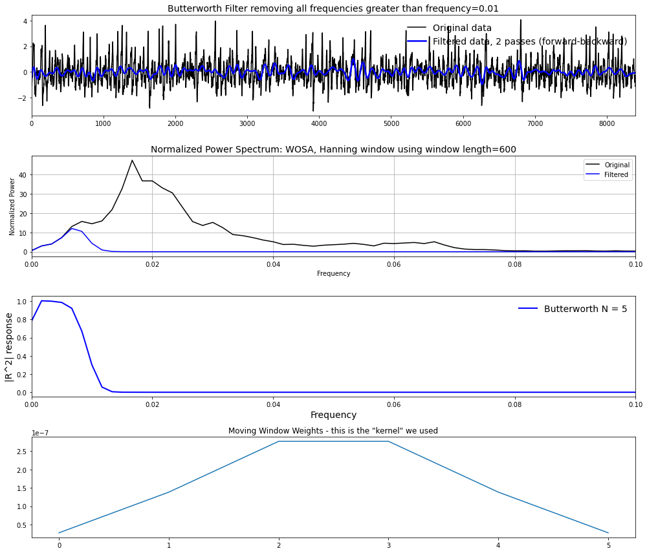

Increasing N increases the tangency of the filter. There is a sharper drop-off in the power spectrum and in the response function above a frequency of 0.01 /month. Correspondingly, the filtered time series begins to look smoother.

1. Assess what is “under the hood” of the python function. How are the edge effects treated? Why is the function filtfilt filtering twice?

It looks like filtfilt goes over edges in each direction (forward and backward). This allows filtering artifacts (e.g., ringing) to propagate forward and backward in time, reducing their overall effect. (Artifacts are symmetrical.) The problem that occurs when one tries to add too steep a filter is that this ringing shows up as power in the Fourier-transformed data. For example, in the “cautionary tale” section of the last notebook:

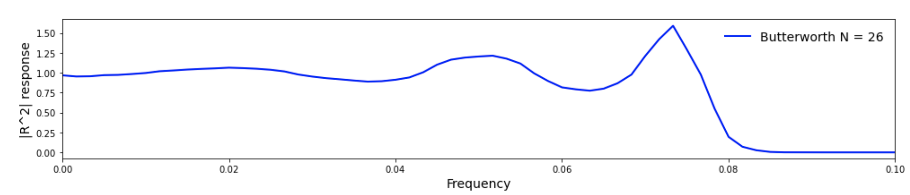

The response peak just below 0.08 /month may be related to this. Why does filtfilt filter twice? I’m still working on understanding this. It allows “making the most of the data”, certainly, but why? It’s advantageous that filtfilt doesn’t move the signal forward or backward in time. The documentation calls this a “zero phase” characteristic.